CCNP Lab 1

2018-2019

Multi-Area OSPF

JEFFREY ZhAng

CCNP: Mason & Hoffman period 6-8

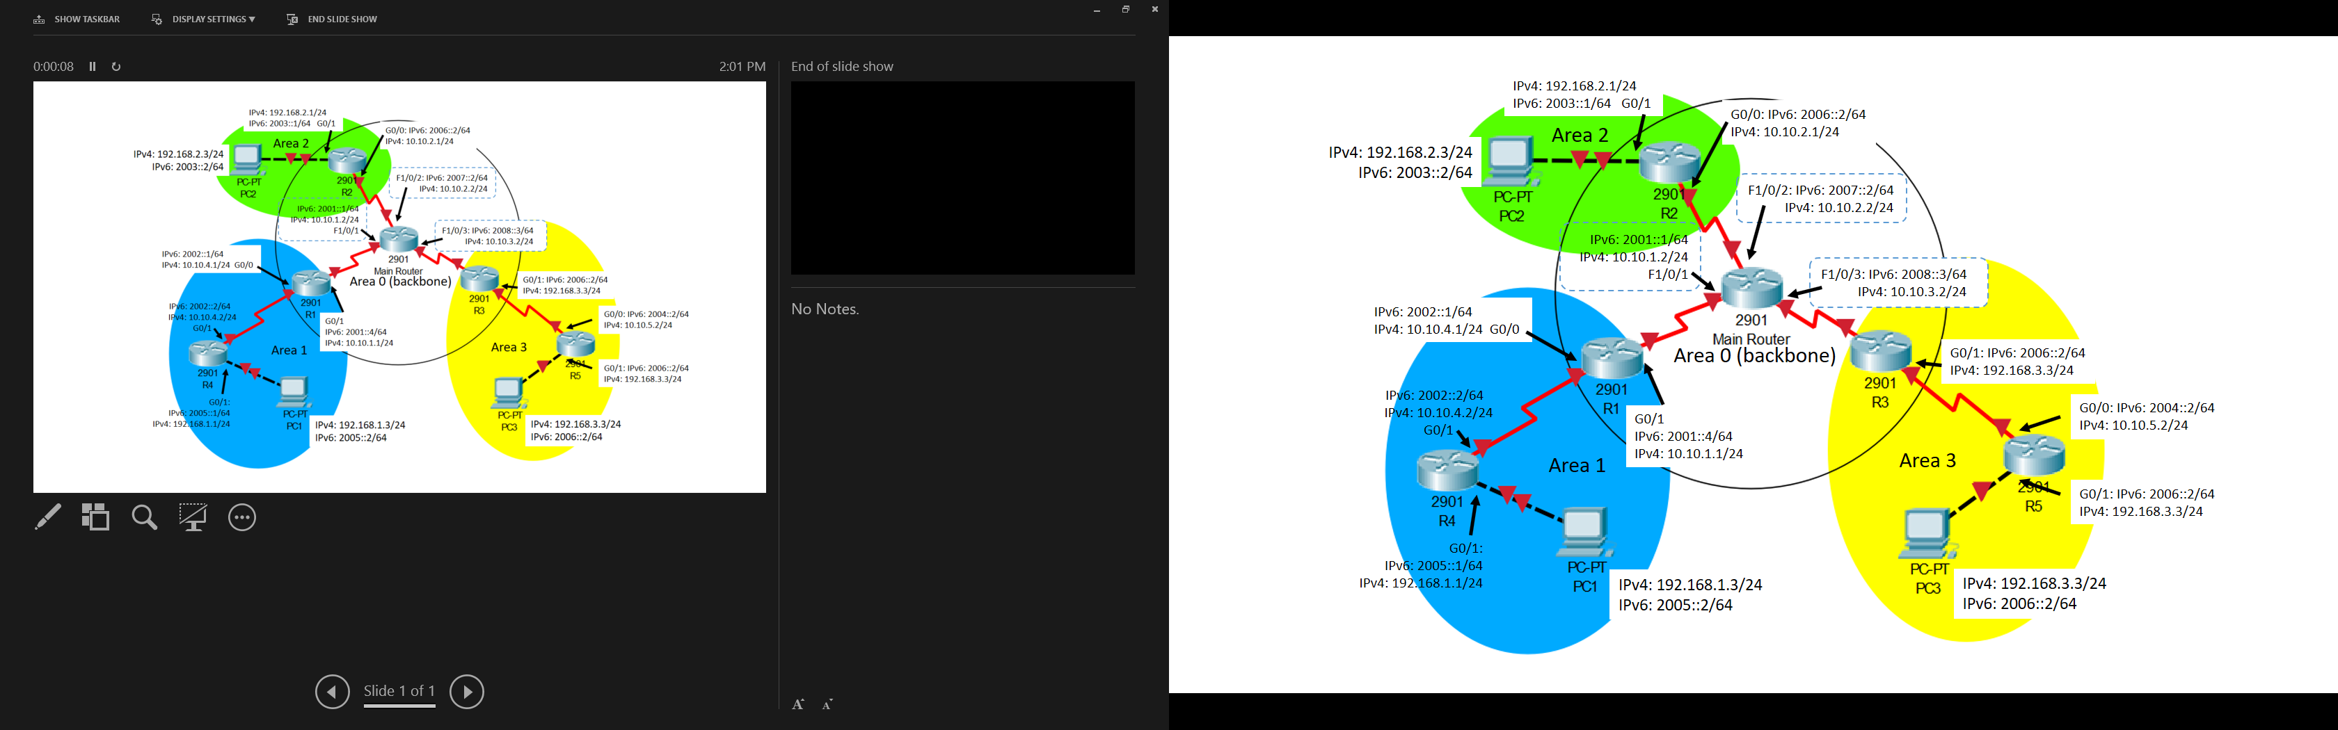

## summary

## Configurations

### Main router (catalyst 3750) config:

hostname MainRouter

ipv6 unicast-routing

spanning-tree mode pvst

interface FastEthernet1/0/1

no switchport

ip address 10.10.1.2 255.255.255.0

ipv6 address 2001::1/64

ipv6 ospf 1 area 0

interface FastEthernet1/0/2

no switchport

ip address 10.10.2.2 255.255.255.0

ipv6 address 2007::2/64

ipv6 ospf 1 area 0

interface FastEthernet1/0/3

no switchport

ip address 10.10.3.2 255.255.255.0

ipv6 address 2008::3/64

ipv6 ospf 1 area 0

router ospf 1

network 10.10.1.0 0.0.0.255 area 0

network 10.10.2.0 0.0.0.255 area 0

network 10.10.3.0 0.0.0.255 area 0

ipv6 router ospf 1

end

### R1 (Cisco 2950 router) config

hostname R1

ipv6 unicast-routing

interface GigabitEthernet0/0

ip address 10.10.1.1 255.255.255.0

duplex auto

speed auto

ipv6 address 2001::4/64

ipv6 ospf 1 area 0

interface GigabitEthernet0/1

ip address 10.10.4.1 255.255.255.0

duplex auto

speed auto

ipv6 address 2002::1/64

ipv6 ospf 1 area 1

router ospf 1

network 10.10.1.0 0.0.0.255 area 0

network 10.10.4.0 0.0.0.255 area 1

ipv6 router ospf 1

end

### R2 (Cisco 2950 router) config

hostname R2

ipv6 unicast-routing

interface GigabitEthernet0/0

ip address 10.10.2.1 255.255.255.0

duplex auto

speed auto

ipv6 address 2007::5/64

ipv6 ospf 1 area 0

interface GigabitEthernet0/1

ip address 192.168.2.1 255.255.255.0

duplex auto

speed auto

ipv6 address 2003::1/64

ipv6 ospf 1 area 2

router ospf 1

router-id 2.2.2.2

network 10.10.2.0 0.0.0.255 area 0

network 192.168.2.0 0.0.0.255 area 2

ipv6 router ospf 1

End

### R3 (CISCO 2950 ROUTER) CONFIG

hostname R3

ipv6 unicast-routing

interface GigabitEthernet0/0

ip address 10.10.3.1 255.255.255.0

duplex auto

speed auto

ipv6 address 2008::6/64

ipv6 ospf 1 area 0

interface GigabitEthernet0/1

ip address 10.10.5.1 255.255.255.0

duplex auto

speed auto

ipv6 address 2004::1/64

ipv6 ospf 1 area 3

router ospf 1

router-id 3.3.3.3

network 10.10.3.0 0.0.0.255 area 0

network 10.10.5.0 0.0.0.255 area 3

ipv6 router ospf 1

end

### R4 (Cisco 2950 router) config

hostname R4

ipv6 unicast-routing

interface GigabitEthernet0/0

ip address 10.10.4.1 255.255.255.0

duplex auto

speed auto

ipv6 address 2002::2/64

ipv6 ospf 1 area 1

interface GigabitEthernet0/1

ip address 192.168.1.1 255.255.255.0

duplex auto

speed auto

ipv6 address 2005::1/64

ipv6 ospf 1 area 1

router ospf 1

router-id 4.4.4.4

network 10.10.4.0 0.0.0.255 area 1

network 192.168.1.0 0.0.0.255 area 1

ipv6 router ospf 1

End

### R5 (Cisco 2950 router) config

hostname R5

ipv6 unicast-routing

interface GigabitEthernet0/0

ip address 10.10.5.2 255.255.255.0

duplex auto

speed auto

ipv6 address 2004::2/64

ipv6 ospf 1 area 0

interface GigabitEthernet0/1

ip address 192.168.3.1 255.255.255.0

duplex auto

speed auto

ipv6 address 2006::1/64

ipv6 ospf 1 area 3

router ospf 1

router-id 5.5.5.5

network 10.10.5.0 0.0.0.255 area 3

network 192.168.3.0 0.0.0.255 area 3

ipv6 router ospf 1

end

## Problems

We had trouble turning a layer 3 switch into a router. To solve this, we first typed “sdm prefer dual-ipv4-and-ipv6 default” command into Global Configuration of the switch. We then saved the config and reload the switch. After doing that, we still couldn’t assign ip address to the ports. So, we did “no switchport” command in that port. Finished with all those steps, a layer 3 switch works the same as a router.

In addition, the routers and switches that we worked with had configurations saved on them. And the previous configurations administratively shutdown some ports, which confused us for a long time (we thought it was a layer one problem). To solve this, we did “erase running-config startup-config” and then reload.

IPv6 Multi-Area OSPF didn’t work properly when we first assigned it. Then, we figured out that we need router-id for each router to make IPv6 OSPF work. After doing that, everything worked fine.

## Conclusion

The purpose of this lab was for us to familiarize with the content we learned last year, with a little advancement of Multi-Area OSPF. Since we didn’t have enough routers, we had to learn how to use a layer 3 switches as routers. After all, it was a good reminder of the things I learnt last year, with a little exploration.

**Teacher Signoff Page of Lab Completed**

